1. **Installation of VS Code: Describe the steps to download and install Visual Studio Code on Windows 11 operating system. Include any prerequisites that might be needed.**

* Download VS Code:
* Visit the official VS Code website.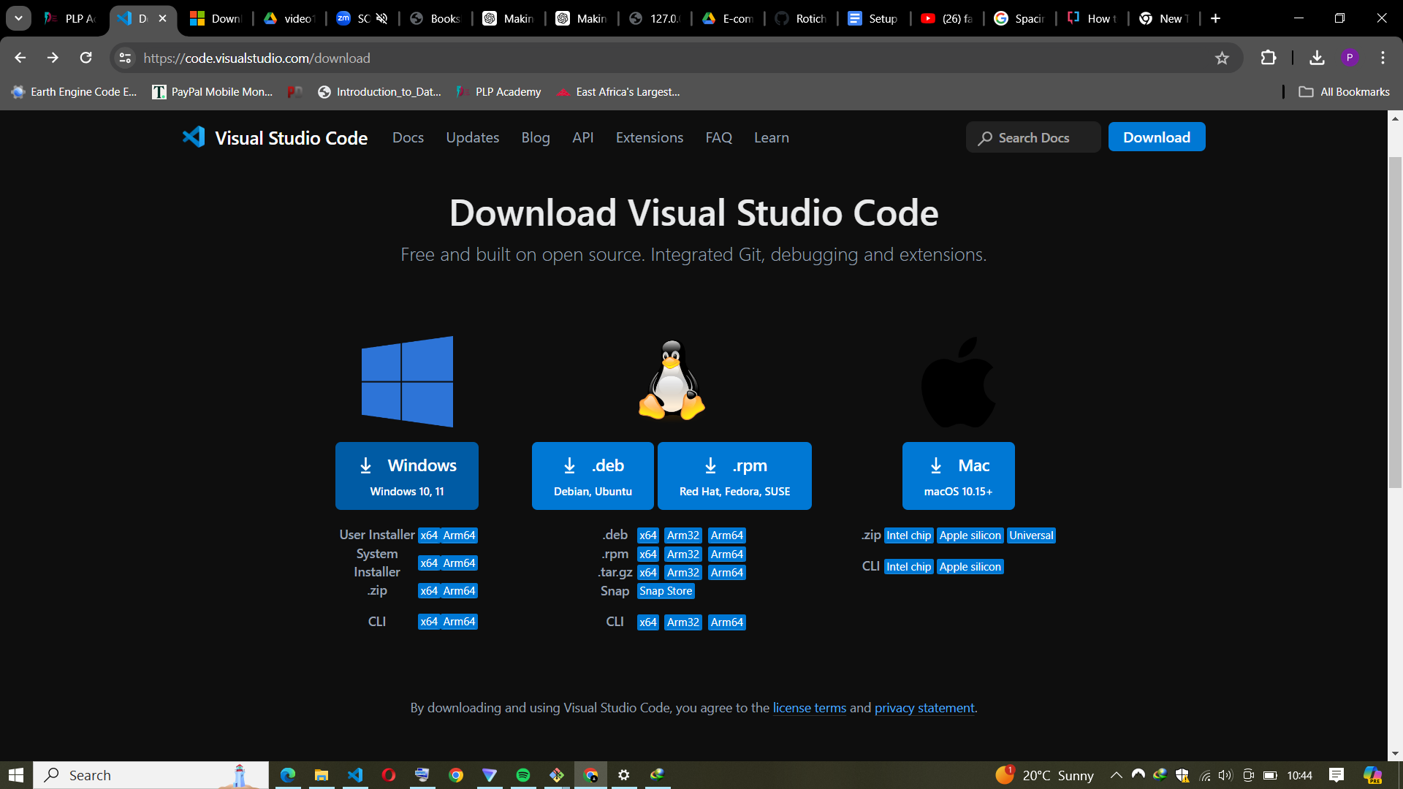
* Click the Windows button to download the installer.
* Save the file on your device.

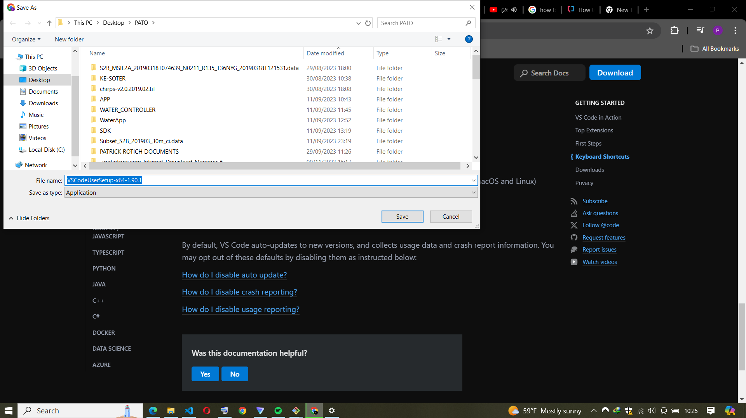

* Install VS Code:
* Double-click the downloaded file (usually named VSCodeUserSetup-{version}.exe).
* Follow the installation prompts. Accept the terms and conditions.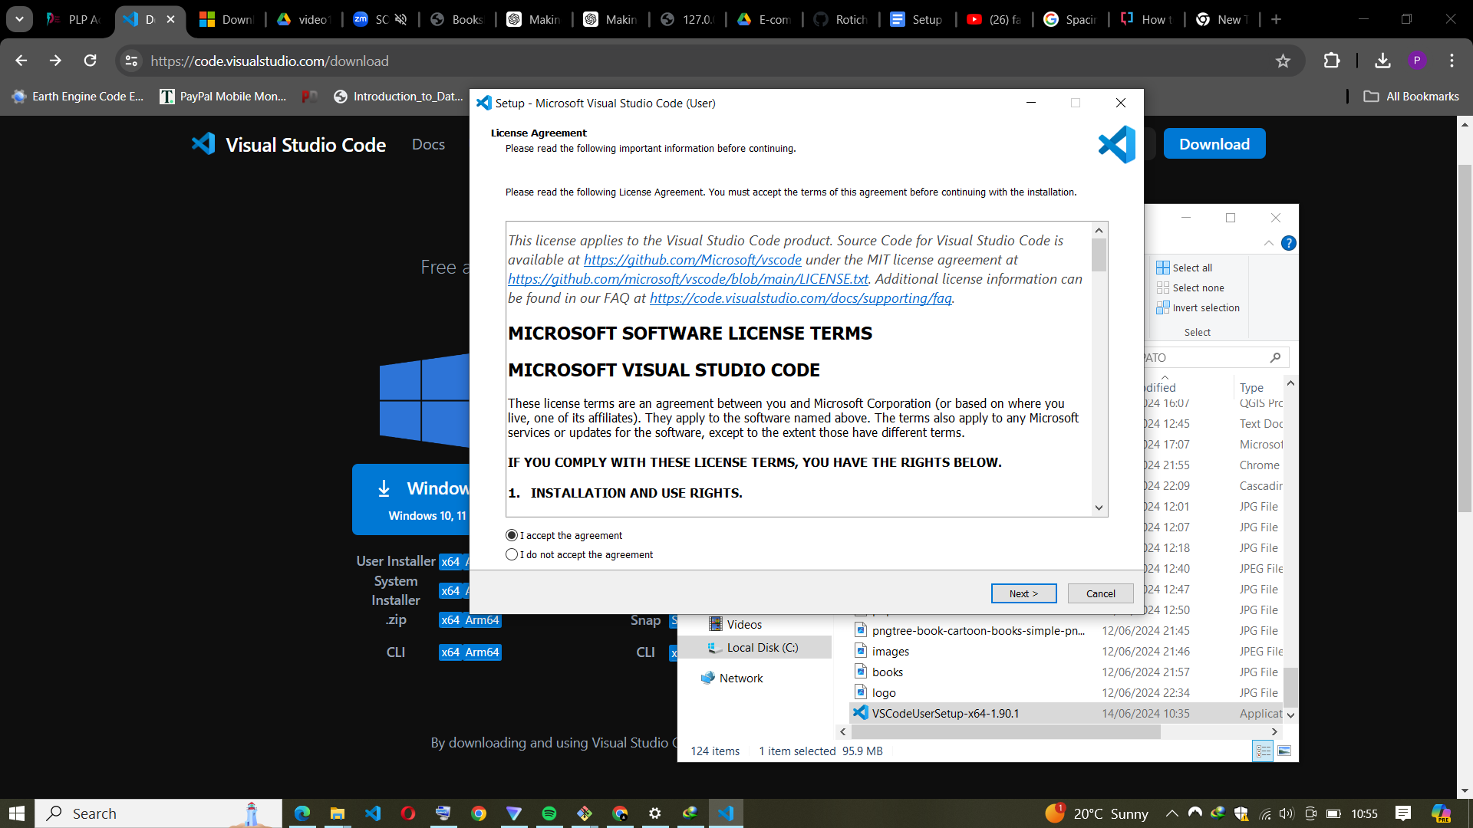
* By default, VS Code will be installed under C:\Users\YourUsername\AppData\Local\Programs\Microsoft VS Code.
* Launch VS Code:
* After installation, click the Launch button to start VS Code.

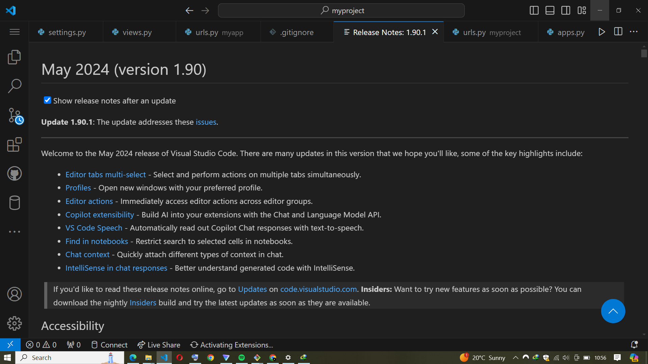

1. **First-time Setup:After installing VS Code, what initial configurations and settings should be adjusted for an optimal coding environment? Mention any important settings or extensions.**

To set up Visual Studio Code (VS Code) for Python development, including working with MySQL and integrating GitHub and GitHub Classroom, follow these initial configurations and settings:

**Basic Configuration**

Set Theme: Go to File > Preferences > Color Theme.

Choose a theme that suits your preference. Popular choices include "Dark+", "Light+", "Monokai", and "Dracula".

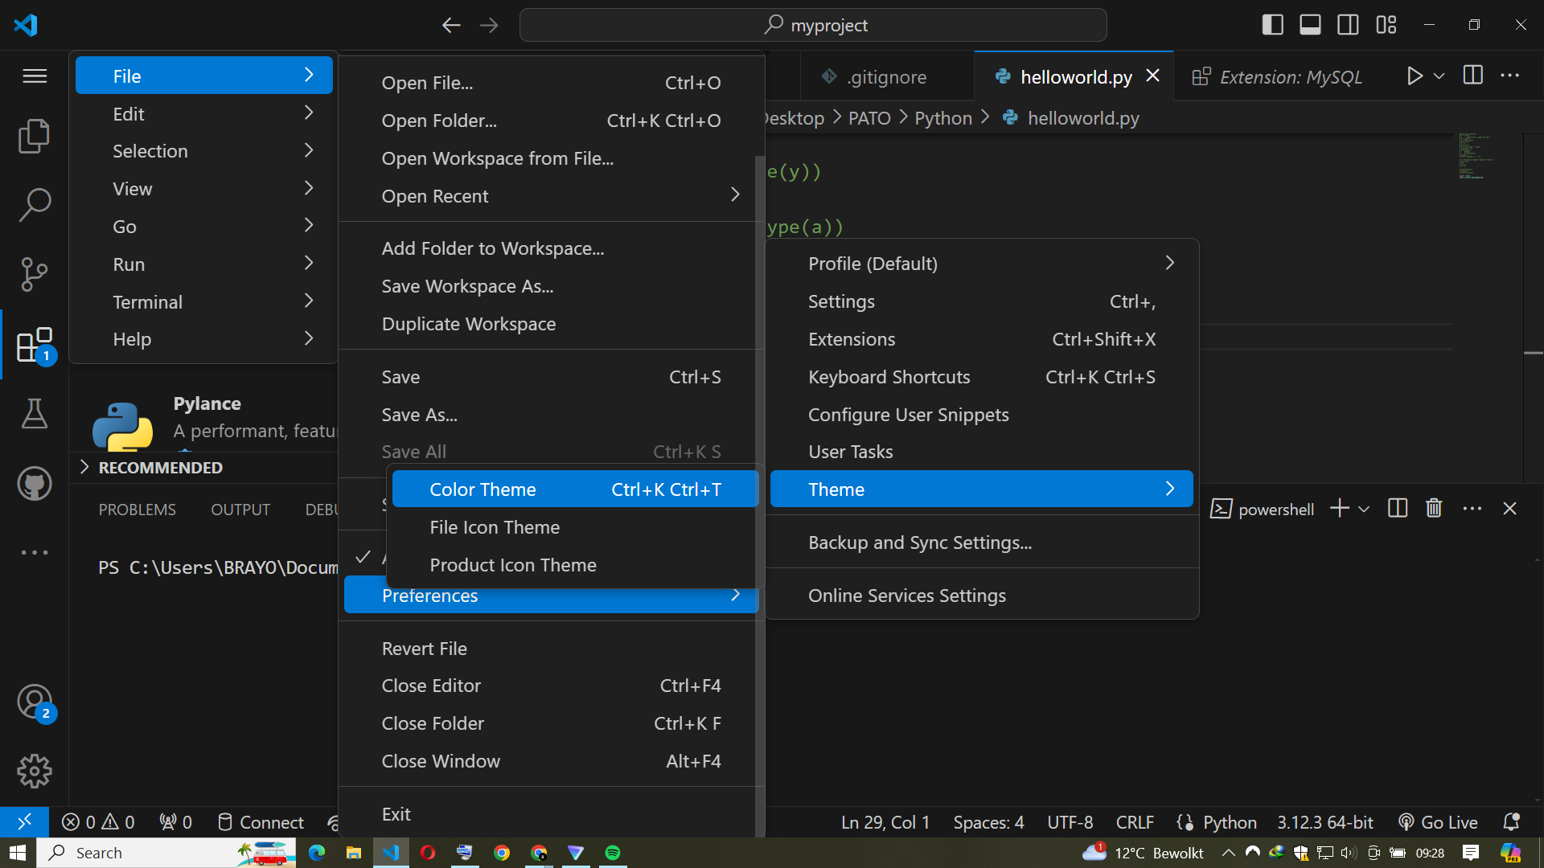

Configure Font and Font Size: Go to File > Preferences > Settings.

Search for "Font" and set the desired Editor: Font Family and Editor: Font Size.

Enable Word Wrap: Go to File > Preferences > Settings.

Search for "Word Wrap" and enable it (Editor: Word Wrap to on).

Configure Auto Save:

Go to File > Preferences > Settings.

Search for "Auto Save" and set it to afterDelay or onWindowChange.

Essential Extensions

**Python:**

Provides rich support for Python including IntelliSense, linting, debugging, and code navigation.

Install from the Extensions view (Ctrl+Shift+X) by searching for "Python".

**Python Debugger:**

Allows you to debug Python scripts with the integrated debugger.

This feature is included with the Python extension.

Pylance:

A fast, feature-rich language support for Python, offering enhanced IntelliSense and type checking.

Install from the Extensions view by searching for "Pylance".

**GitHub:**

Integrates GitHub directly into VS Code for version control and repository management.

Install from the Extensions view by searching for "GitHub".

**MySQL:**

Provides tools for MySQL database management and querying.

Install the "MySQL" extension or "SQLTools" with the MySQL driver from the Extensions view by searching for "MySQL".

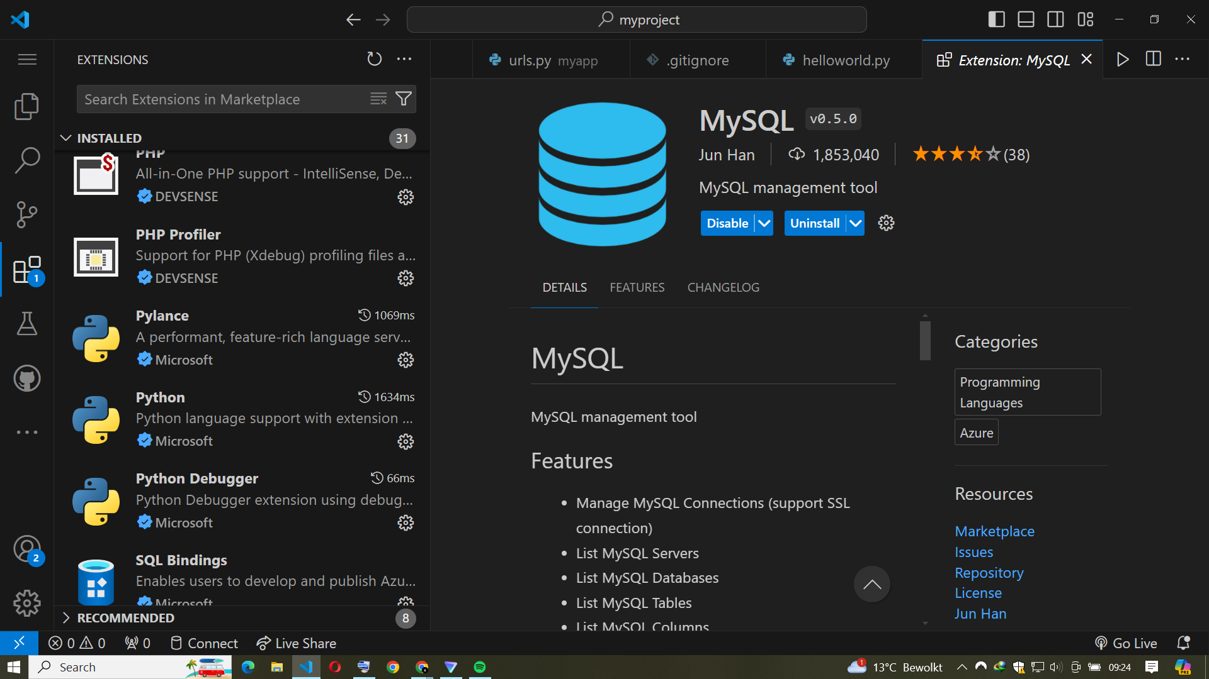

**GitHub Classroom:**

Integrates GitHub Classroom into VS Code for managing classroom assignments.

Install from the Extensions view by searching for "GitHub Classroom".

**Configure Python-Specific Settings**

Set Python Interpreter:

Open the command palette (Ctrl+Shift+P).

Type Python: Select Interpreter and select the Python interpreter you want to use (e.g., a virtual environment or system interpreter).

**Enable Format on Save:**

Go to File > Preferences > Settings.

Search for "Format On Save" and enable it.

1. **User Interface Overview: Explain the main components of the VS Code user interface. Identify and describe the purpose of the Activity Bar, Side Bar, Editor Group, and Status Bar.**

Activity Bar

The Activity Bar is located on the far left side of the interface. It provides quick access to different views and primary functions of VS Code through icons. Each icon represents a specific activity, such as:

* Explorer: Manages and navigates project files and folders.
* Search: Performs text searches across files in the workspace.
* Source Control: Integrates Git and other version control systems.
* Run and Debug: Accesses debugging functionalities and configurations.
* Extensions: Manages VS Code extensions, allowing users to install, update, or remove them.

The Activity Bar helps in quickly switching between these essential tools, enhancing productivity.

Side Bar

The Side Bar is adjacent to the Activity Bar and displays the contents of the selected activity. For example:

* Explorer View: Shows the file and folder structure of the workspace.
* Search View: Provides search results and allows for advanced search options.
* Source Control View: Displays Git repositories, staged/unstaged changes, and commit history.
* Extensions View: Lists installed extensions and recommendations, enabling easy management.
* The Side Bar is context-sensitive and changes according to the selected activity, offering detailed and relevant information and controls.

Editor Group

The Editor Group is the central part of the interface where files are opened and edited. It supports multiple tabs, allowing users to work on several files simultaneously. Key features include:

* Tabs: Multiple files can be opened in tabs for easy switching.
* Split Views: The editor can be split into multiple columns or rows, enabling side-by-side editing of files.
* Syntax Highlighting: Provides language-specific features such as syntax coloring, auto-completion, and error checking.

The Editor Group is where the majority of coding and file editing takes place, making it the core workspace of VS Code.

Status Bar

The Status Bar is located at the bottom of the interface and provides information and shortcuts related to the current workspace and file. It displays:

* Current Git Branch: Shows the active branch in the version control system.
* Line and Column Numbers: Indicates the cursor's position in the active file.
* Encoding and EOL: Displays the file encoding and end-of-line sequence.
* Language Mode: Shows the language of the current file and allows for quick changes.
* Notifications and Warnings: Displays issues, errors, and other notifications.

The Status Bar provides contextual information and quick access to common settings, enhancing workflow efficiency.

1. **Command Palette: What is the Command Palette in VS Code, and how can it be accessed? Provide examples of common tasks that can be performed using the Command Palette.**

The Command Palette in VS Code is a powerful feature that provides quick access to various commands and functionalities within the editor. It serves as a centralized command center, allowing users to execute tasks without navigating through menus.

The Command Palette can be accessed in two main ways:

* Keyboard Shortcut: Press Ctrl+Shift+P (or Cmd+Shift+P on macOS).
* Menu Access: Go to the menu bar and select View > Command Palette.

Common tasks that can be performed using the Command Palette:

**Switching Themes:**

Type Preferences: Color Theme to quickly change the editor's color theme.

**Installing Extensions:**

Type Extensions: Install Extensions to open the extensions view and search for new extensions to install.

**Running Debug Configurations**:

Type Debug: Start Debugging to start a debugging session with the active configuration.

**Opening Files**:

Type File: Open File to open a specific file by name.

**Git Commands:**

Type Git: Commit to commit changes, Git: Pull to pull the latest changes, or Git: Push to push commits to the remote repository.

**Formatting Code:**

Type Format Document to format the entire file according to the configured formatter.

**Terminal Commands:**

Type Terminal: Create New Integrated Terminal to open a new terminal within VS Code.

1. **Extensions in VS Code: Discuss the role of extensions in VS Code. How can users find, install, and manage extensions? Provide examples of essential extensions for web development.**

Extensions in Visual Studio Code (VS Code) play a crucial role in enhancing its functionality and customizing the editor to meet specific development needs. They allow users to add new features, integrate with external tools, support additional programming languages, and optimize the development workflow. Extensions can significantly improve productivity and provide a more robust development environment tailored to individual or project requirements.

**Finding Extensions:**

Extension View: Within VS Code, the Extensions view can be opened by clicking the Extensions icon in the Activity Bar or pressing Ctrl+Shift+X (or Cmd+Shift+X on macOS).

**Installing Extensions:**

Open Extensions View: Press Ctrl+Shift+X (or Cmd+Shift+X on macOS).

Search for Extensions: Use the search bar at the top of the Extensions view.

Install: Click the "Install" button next to the desired extension. Extensions are enabled automatically upon installation.

**Managing Extensions:**

Enable/Disable: Right-click an extension in the Extensions view and select "Enable" or "Disable".

Update: Click the "Update" button if an update is available for an installed extension.

Uninstall: Right-click the extension in the Extensions view and select "Uninstall".

**Essential Extensions for Web Development**

**Live Server:**

Launches a local development server with live reload feature, providing real-time feedback during development.

**Prettier - Code Formatter:**

An opinionated code formatter that supports many languages, ensuring consistent code style.

**ESLint:**

Integrates ESLint for identifying and fixing linting issues in JavaScript and TypeScript code.

**HTML CSS Support:**

Provides CSS class name completion for HTML class attributes based on workspace CSS files.

**JavaScript Code Snippets:**

Offers ES6 syntax snippets, speeding up coding.

**Path Intellisense:**

Autocompletes filenames in the project, reducing errors and speeding up linking.

**Debugger for Chrome:**

Enables debugging of JavaScript code in Chrome, essential for front-end development.

**GitLens:**

Enhances Git capabilities with insights into code changes, authors, and history.

Extensions transform VS Code from a simple code editor into a robust, versatile development environment, making it ideal for web developers and many other programming disciplines.

1. **Integrated Terminal: Describe how to open and use the integrated terminal in VS Code.**

Visual Studio Code includes a full featured integrated terminal that starts at the root of your workspace. It provides integration with the editor to support features like links and error detection. The integrated terminal can run commands such as mkdir and git just like a standalone terminal.

You can open a terminal as follows:

From the menu, use the Terminal > New Terminal or View > Terminal menu commands.From the Command Palette (Ctrl+Shift+P), use the View: Toggle Terminal command.

In the Explorer, you can use the Open in Integrated Terminal context menu command to open a new terminal from a folder.

To toggle the terminal panel, use the Ctrl+` keyboard shortcut. To create a new terminal, use the Ctrl+Shift+` keyboard shortcut.

**What are the advantages of using the integrated terminal compared to an external terminal?**

The integrated terminal in VS Code enhances productivity by providing a seamless, unified workspace for coding and terminal tasks. It offers quick access, consistent environment settings, multiple terminal instances, split views, customization, and integration with extensions, all within the same window, reducing context switching and improving workflow efficiency.

1. **File and Folder Management: Explain how to create, open, and manage files and folders in VS Code. How can users navigate between different files and directories efficiently?**

Creating Files and Folders:

Create a New File: Right-click in the Explorer view and select New File or use the shortcut Ctrl+N (Cmd+N on macOS).

Name the file and press Enter.

Create a New Folder: Right-click in the Explorer view and select New Folder.

Name the folder and press Enter.

**Open a File:**

Use File > Open File... or Ctrl+O (Cmd+O on macOS) to open a specific file.

You can also double-click a file in the Explorer view.

**Open a Folder:**

Use File > Open Folder... or Ctrl+K Ctrl+O (Cmd+K Cmd+O on macOS) to open a folder as a workspace.

**Move Files/Folders:**

Drag and drop files or folders within the Explorer view.

**Rename Files/Folders:**

Right-click the file or folder and select Rename, or press F2.

**Delete Files/Folders:**

Right-click and select Delete, or press Delete key.

Navigating Between Files and Directories:

**Quick Open:**

Use Ctrl+P to open the Quick Open dialog and type the name of the file you want to open.

**Explorer View**:Use the Explorer view for a tree-like structure of your workspace.

**Breadcrumbs**: Use the breadcrumbs at the top of the editor to navigate through the directory structure.

**Go to Definition/References**: Use F12 to go to a symbol's definition or Shift+F12 to find references.

1. **Settings and Preferences: Where can users find and customize settings in VS Code? Provide examples of how to change the theme, font size, and keybindings.**

How users can find and customize settings for themes, font sizes, and keybindings:

**Accessing Settings**

Using the Settings UI: Open VS Code and navigate to File > Preferences > Settings. This opens the Settings tab where users can browse and modify settings through a user-friendly interface.

**Editing settings.jso**n: For advanced customization or direct JSON editing, users can access settings.json by either:

Opening the Command Palette (Ctrl+Shift+P), typing Preferences: Open Settings (JSON), and pressing Enter.

Manually locating the file in the VS Code configuration directory (%APPDATA%\Code\User\settings.json on Windows

,~/.config/Code/User/settings.json on Linux, ~/Library/Application Support/Code/User/settings.json on macOS).

Customization Examples

**Changing the Theme**

Using the Settings UI: Navigate to File > Preferences > Color Theme.

Choose a theme from the list provided, such as "Dark+" for a dark theme.

Editing settings.json:

Add "workbench.colorTheme": "Dark+" to settings.json to set the dark theme.

**Adjusting Font Size**

Using the Settings UI: Search for Editor: Font Size in the Settings tab.

Adjust the value to change the font size, like "editor.fontSize": 14.

Editing settings.json: Add "editor.fontSize": 14 directly in settings.json to set the font size to 14 pixels.

Customizing Keybindings

Using the Settings UI: Navigate to File > Preferences > Keyboard Shortcuts.

Search for the desired command or keybinding and modify it using the provided interface.

Editing keybindings.json: Open keybindings.json by selecting Preferences: Open Keyboard Shortcuts (JSON) from the Command Palette.

1. **Debugging in VS Code: Outline the steps to set up and start debugging a simple program in VS Code. What are some key debugging features available in VS Code?**

Outline of the steps to set up and start debugging a simple program:

Install Necessary Extensions

Open your project folder in VS Code. Create or Open the Program File:

Navigate to the file containing the code you want to debug. If the file doesn't exist, create it.

Set Breakpoints: Click in the gutter next to the line number where you want to set a breakpoint. A red dot indicates a breakpoint is set. Breakpoints pause program execution at specific points to inspect variables and state.

Start Debugging: Open the Run view by clicking on the Run icon in the Activity Bar on the side or pressing Ctrl+Shift+D (Cmd+Shift+D on macOS).

Click on the green play button next to the configuration you want to use (e.g., "Launch Program").

Alternatively, press F5 to start debugging with the default launch configuration.

Debugging Controls: Use the debugging controls in the top menu or the debug toolbar to step through code (F10 for step over, F11 for step into, Shift+F11 for step out), continue execution (F5), pause (F6), or stop debugging (Shift+F5).

**Key Debugging Features in VS Code**

Variable Inspection: Hover over variables to see their current values or add them to the Watch panel for continuous monitoring.

Call Stack Navigation: View and navigate through the call stack to understand the program's execution flow.

Integrated Terminal:Access an integrated terminal within VS Code for debugging interactive programs or executing commands.

Debug Console: Use the debug console to evaluate expressions, execute commands, or interact directly with the program during debugging sessions.

Multi-Session Debugging: Debug multiple sessions simultaneously, useful for debugging client-server applications.

1. **Using Source Control: How can users integrate Git with VS Code for version control? Describe the process of initializing a repository, making commits, and pushing changes to GitHub.**

Integrating Git with Visual Studio Code (VS Code) for version control is seamless and enhances collaborative development workflows. Here’s a step-by-step process from initializing a repository to pushing changes to GitHub:

**Initializing a Repository**

Open your project folder in VS Code.

Initialize Git Repository: Open the integrated terminal in VS Code (Ctrl+`` or Cmd+``).

Navigate to your project directory.

Run the command git init to initialize a new Git repository.

**Making Commits**

Stage Changes: Use the Source Control view (Ctrl+Shift+G) to see changes in your project.

Click the + button next to files to stage them for commit.

**Commit Changes:**

Enter a commit message that describes the changes.

Click the check mark icon (√) in the Source Control view or use Ctrl+Enter to commit changes.

**Pushing Changes to GitHub**

Connect to GitHub: Install the GitHub extension for VS Code if not already installed.

Authenticate with your GitHub account by following the prompts.

Create a Remote Repository: Go to GitHub and create a new repository (if not already created).

Link Local Repository to Remote:

In VS Code, go to the Source Control view.

Click on the ellipsis (...) next to the repository name and select Publish to GitHub.

Choose the repository name and confirm the publishing.

Push Changes: After publishing, you can push your local commits to the remote repository by clicking the sync icon (↻) in the status bar or using the Push command in the Source Control view.

**SOURCES**

1. <https://www.xda-developers.com/download-windows-11/>
2. [https://www.youngwonks.com/blog/how-to-open-terminal-in-visual-studio-code#:~:text=One%20of%20the%20key%20advantages,commands%20and%20version%20control%20operations.](https://www.youngwonks.com/blog/how-to-open-terminal-in-visual-studio-code#:~:text=One%20of%20the%20key%20advantages,commands%20and%20version%20control%20operations)
3. <https://code.visualstudio.com/docs/editor/versioncontrol>
4. <https://code.visualstudio.com/docs/editor/github>